|  |
| --- |
| Circle Language Spec: System Objects |

## Explicit Get & Set Notation

Assignment has a special, simplified notation covered in the *Assignment* articles. But you can also display the Get and Set of the assignment explicitly. This notation is only required when there is no simplified notation available for what you want. However, explicit notation of Get and Set can always be used in *abstract* diagram expression just to make a point.

The following are examples of explicit Get and Set notations. It works for any Get, Set or Use that you want to combine together.

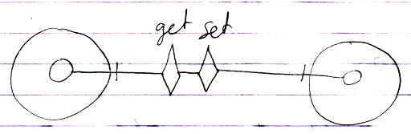

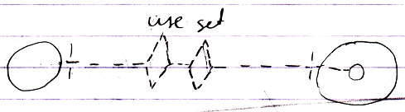

The line types of the system commands express which aspect a command is called upon. The line in between the two system commands is basically a line type that looks best in that situation: if the whole operation is typical to the use of the Class aspect you could make it dashed, if the operation is a more uncommon cross-aspect action, then you could just use a solid line by default.

When you look at the aspects introduced so far, the only time you may need the explicit Get & Set notation is in a Class Get – Class Set assignment.

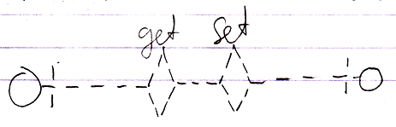

Whenever a simpler notation is available, such as an assignment notation, the simpler notation is used, however, alternative notations can *always* be used to simply express a point in *abstract* diagram notation.